Sweat Themes: An Experiment in Turned-Type

One of my favourite typos is the turned-type error, where a single letter sort gets locked into the chase upside-down. So what should be an n is set as a u (or vice-versa); what should be a p might be a d. You may even get an e for an a. And sometimes the typo produces a word which makes as much - or more - sense that its alternative. So Shakespeare editors have to wrestle with Othello’s line that he ‘like the base Indean threw a pearl away’ (Othello V.ii.347): if we imagine a turn-type error here, then Indean becomes Iudean, or Judean. A reference to Judas makes more sense in this context, doesn’t it? Perhaps we should disregard the printed evidence in the earliest copies; perhaps we should assume that an error has occurred.
So this was the plan: firstly, take a lexicon of all the words used in Shakespeare’s works, around 20,000 unique terms in total; then write a computer program which takes each of these words and tries flipping its letters upside-down to see if we end up with another valid word from the same dictionary. The options I coded for were p and d, b and q, u and n, a and e, and f and s (the long s shape in early printing can easily by mistaken for an f at the compositing stage). Allowing for all of these, one ends up with a surprisingly large number of potentially ambiguous words: about 600 of them. A lot of them are only ambiguous within quite a narrow semantic field: Kentishman vs Kentishmen, for example. But some are more fun: fancy vs saucy, or the ultra-slippery pan, pen, peu, dan, den. Now we can play at the Compositor’s Constraint: to give ourselves a sense of how wrong a printed text might be by writing something that is maximally ambiguous, something that uses as many of these upside-down words as possible.
Here’s what I came up with: a pair of poems. They’re called ‘Sweat Themes’, after the famous line from Spenser’s ‘Prothalamion’ (often incorrectly set as ‘Sweet Thames’), but also because there seems to be a lot of sweating going on in both of them.
The first version looks like it’s set in a print shop:
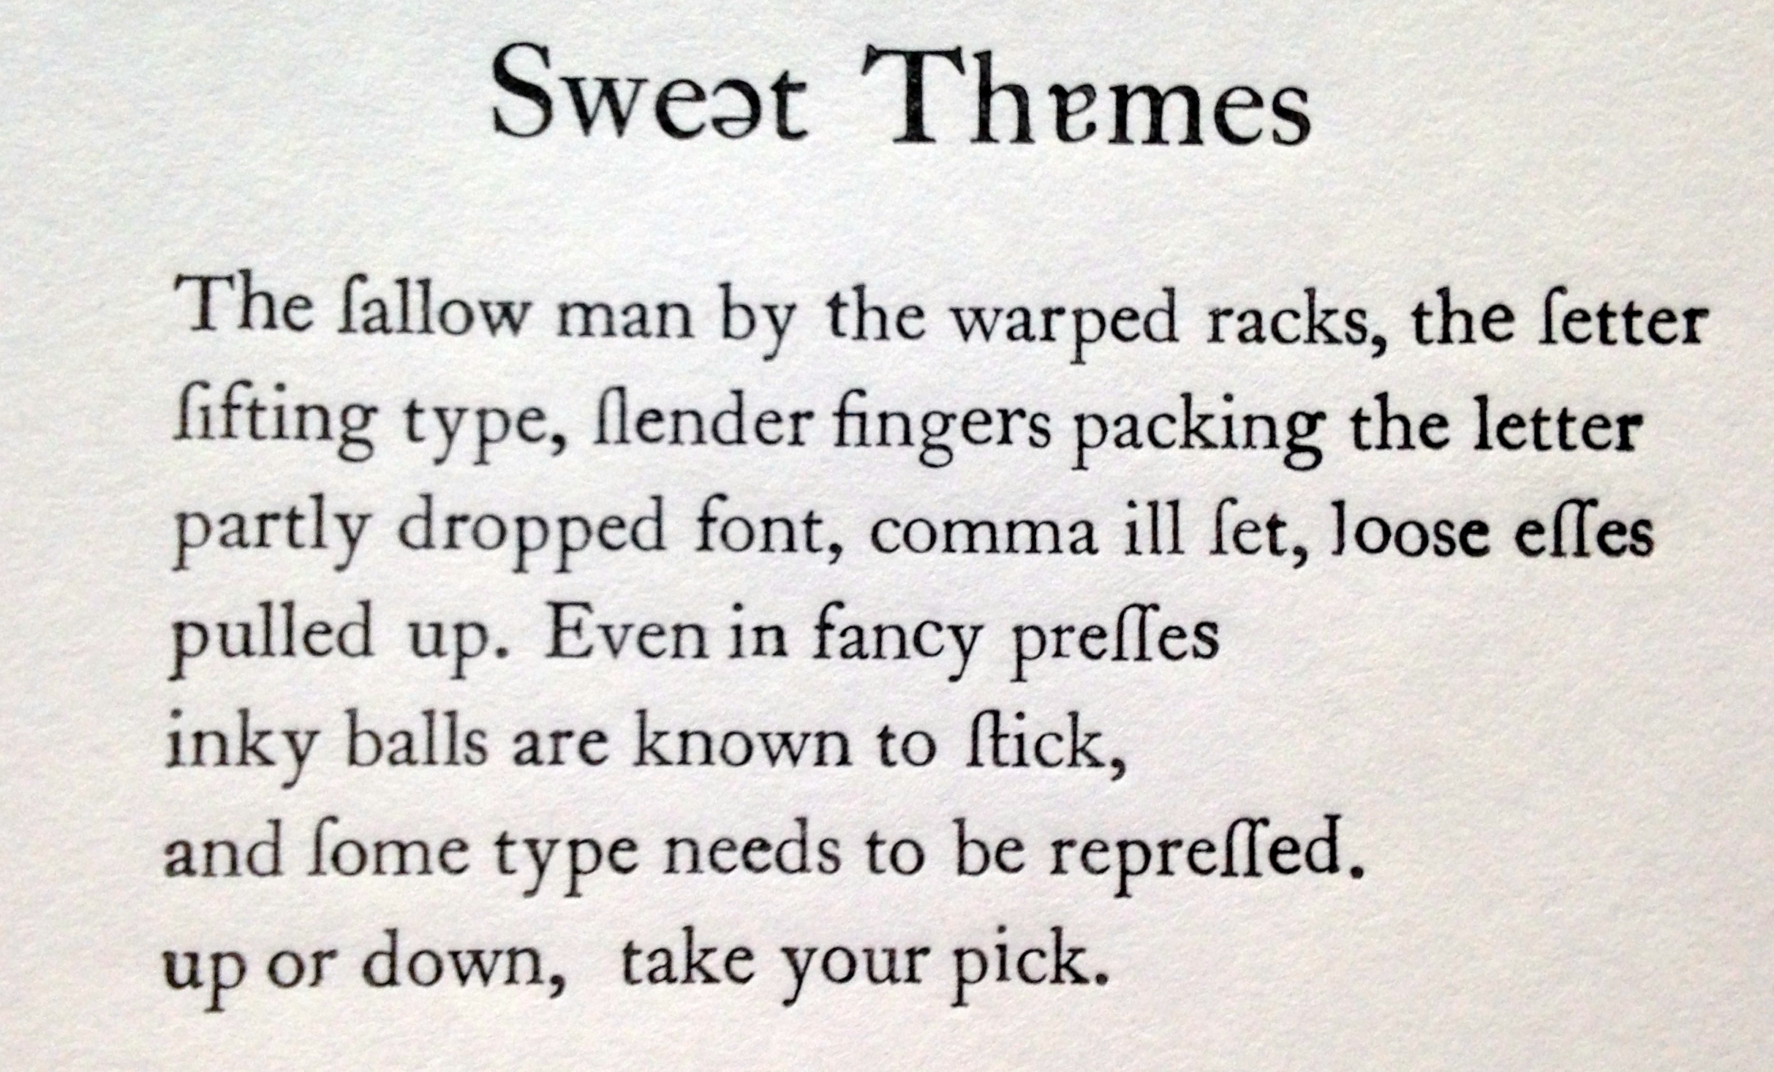

But that is not what I meant at all! Obviously, it’s supposed to be a poem about an orgy in a dungeon. Here, of course, is the correct version:

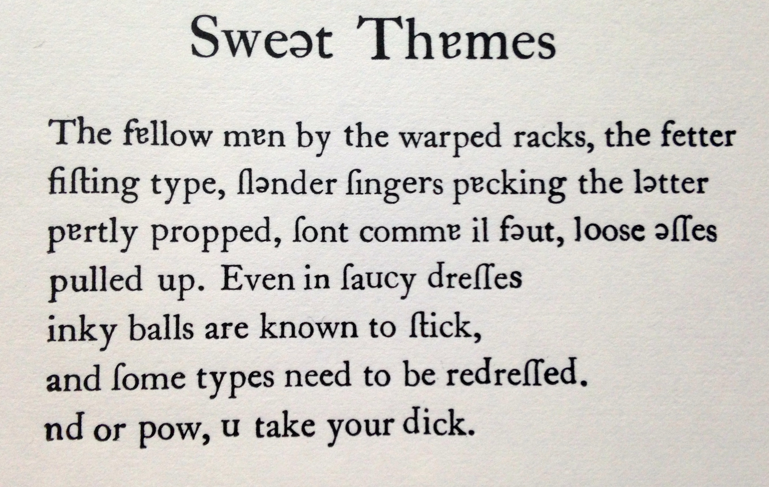

This barely scratches the surface of the corpus of flippable words. What about pigs and digs; dies vs pies; the wise wife who’s weeping or possibly weeding because she’s dowerless or maybe powerless. There are fishy terms: carp (card), fin (sin), sole (sola), dace (pace), bass (bess), battered (bettered); boozy ones – fancy ales like becks become saucy, alas, like backs; and semantic leaps from common to proper nouns: orphans to orpheus; are you in denial, or are you, in fact, in daniel? For the radical doubter, even a straightforward document opens onto a world of instability, all Surrealist imagery and Modernist grammar. And all because of carelessness in the printshop: too-casual typesetting or getting too heavy-handed with the ink dabber. As Boney M so memorably meant to say, Oh, those ruffians!

